**Name: Munna Chauhan**

**Reg. No.: CH.EN.U4CSE22176**

**Experiment No: 04**

**----------------------------------------------------------------------------------------------------------------------------------------------**

Aim: To write a program in YACC for parser generation.

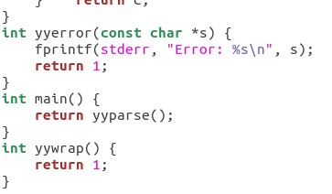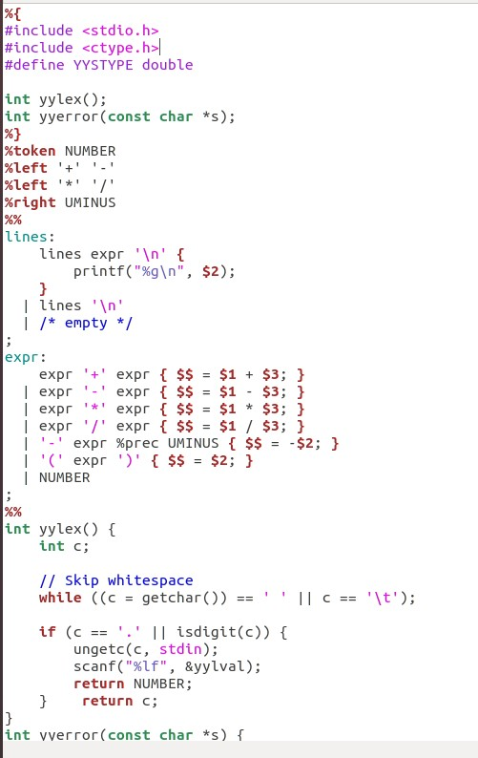Code:

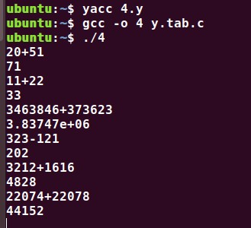 **Output:**

**Results:**

The program in YACC for parser generation has been executed successfully